- Install nginx and run nginx on port number 81.
sudo yum install nginx -y
sudo systemctl start nginx
sudo systemctl enable nginx
sudo systemctl status nginx
Access in Browser by using public ip
Change Nginx Port to 81
sudo vi /etc/nginx/nginx.conf
Find this line:
listen 80;
Change it to:
listen 81;
ESC → :wq → Enter
And do some changes in AWS EC2
Add inbound rules in security group (add port no:81)
sudo systemctl restart nginx
Verify Port 81
sudo netstat -na | grep nginx
Access in Browser by using public ip
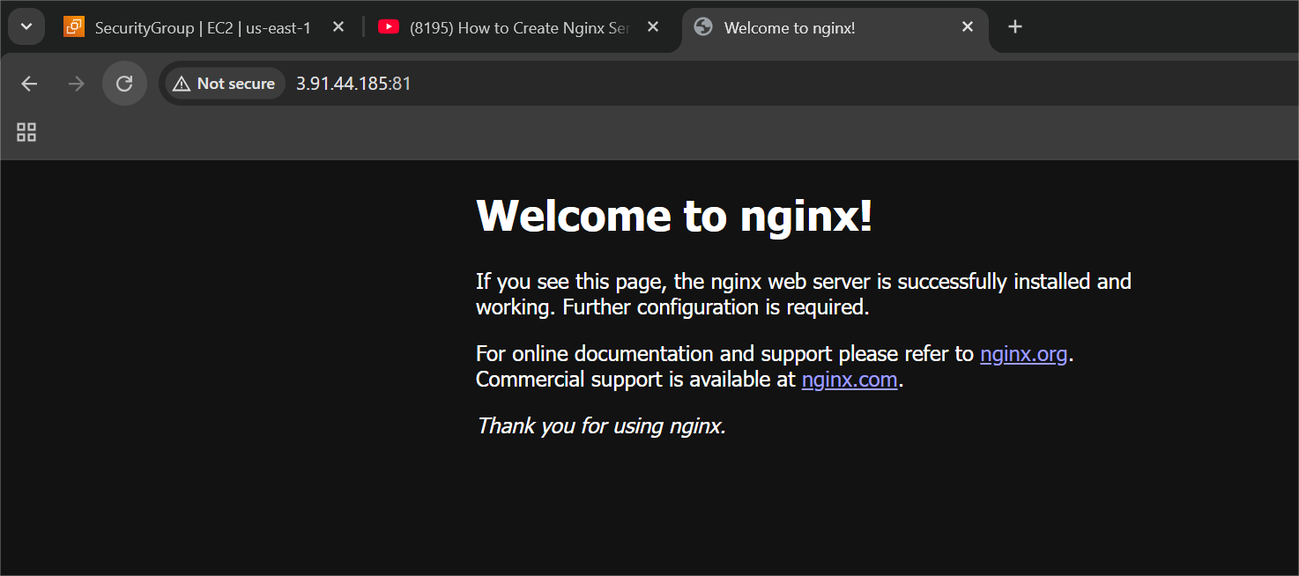

- Deploy a sample index.html file on nginx.
Go to Nginx Web Root Directory
cd /usr/share/nginx/html
ls
Create New Sample index.html
sudo vi index.html
<!DOCTYPE html>
<html>
<head>
<title>Hello this is abhinay</title>
</head>
<body>
<h1>thank you</h1>
<p>Deployed Successfully on Port 81</p>
</body>
</html>
ESC → :wq → Enter
Set Proper Permissions
sudo chmod 644 index.html
sudo systemctl restart nginx
Test in Browser by using public id

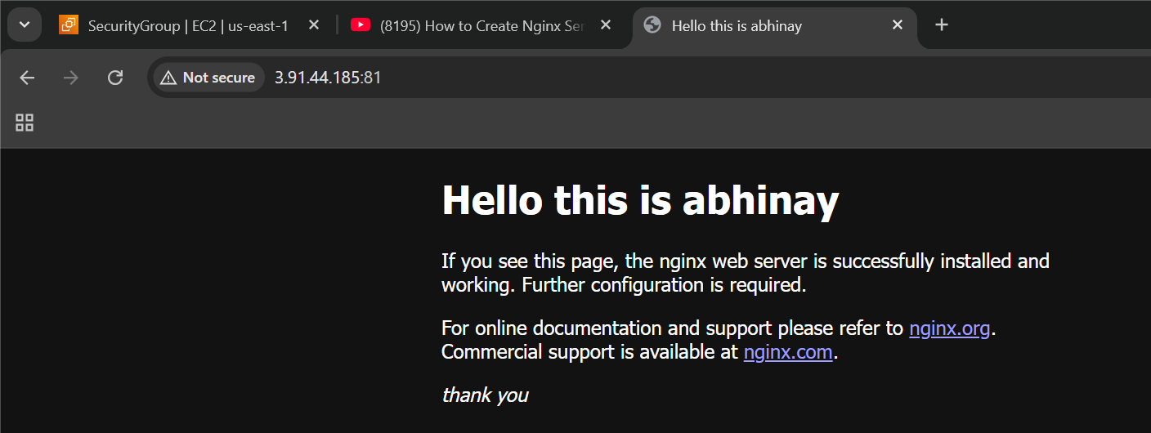
- Install Apache and run Apache on port number 82
Install Apache
sudo yum install httpd -y
sudo systemctl start httpd
sudo systemctl enable httpd
sudo systemctl status httpd
check in browser by using public id and then we continue to change port number
Change Apache Port to 82
sudo vi /etc/httpd/conf/httpd.conf
Find:
Listen 80
Change to:
Listen 82
And do some changes in AWS EC2
Add inbound rules in security group (add port no:82)
Restart Apache
sudo systemctl restart httpd
sudo netstat -na | grep httpd
Access in Browser by using public ip
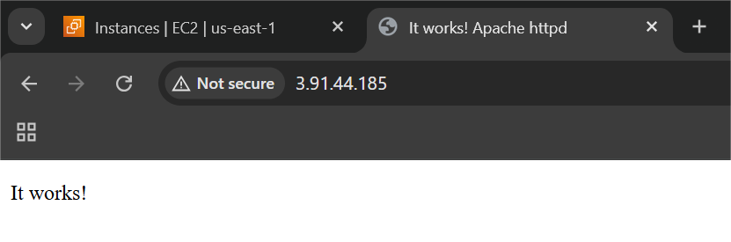

- Deploy a sample index.html file on Apache.
Go to Apache Web Root Directory
cd /var/www/html
Create New index.html File
sudo vi index.html
<!DOCTYPE html>
<html>
<head>
<title>Hello this is abhinay</title>
</head>
<body>
<h1> Hello this is abhinay</h1>
<p>Running on Port 82</p>
</body>
</html>
ESC → :wq → Enter
Set Proper Permissions
sudo chmod 644 index.html
sudo systemctl restart httpd
Test in Browser by using public ip
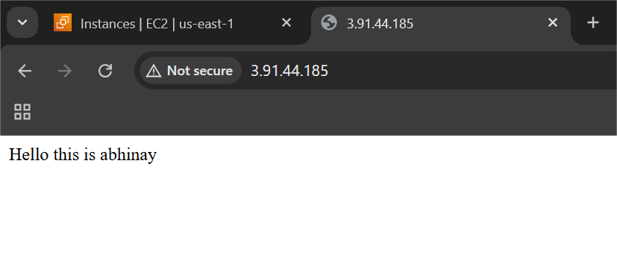
- Install Apache tomcat on port number 8082
Install Java (Required for Tomcat)
Check Java:
java -version
sudo yum install java-11-openjdk -y
Verify:
java -version
Download Apache Tomcat
Go to /opt directory: cd /opt
Download Tomcat (Example: Version 9)
sudo wget https://downloads.apache.org/tomcat/tomcat-9/v9.0.85/bin/apache-tomcat-9.0.85.tar.gz
Extract:
sudo tar -xvzf apache-tomcat-9.0.85.tar.gz
Change Tomcat Port to 8082
Edit server.xml:
sudo vi /opt/tomcat/conf/server.xml
Find this line:
<Connector port="8080" protocol="org.apache.coyote.http11.Http11NioProtocol"
Change:
port="8082"
Example:
<Connector port="8082" protocol="org.apache.coyote.http11.Http11NioProtocol"
And do some changes in AWS EC2
Add inbound rules in security group (add port no:8080 and 8082)
Start Tomcat:
./startup.sh
Verify Tomcat is Running
sudo netstat -na | grep 8082
Access in Browser by using public ip
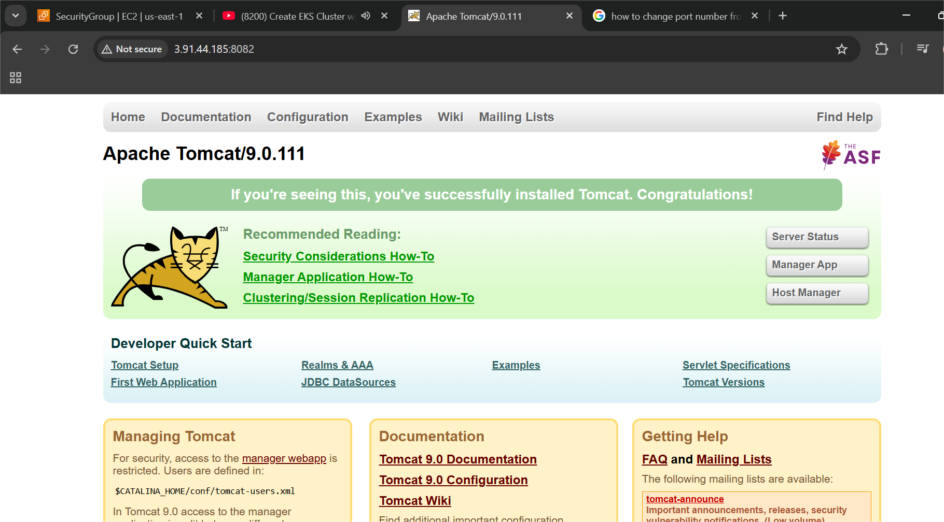

- Deploy a sample app on webapps
Go to webapps Folder
cd /opt/tomcat/webapps
Create App Directory
sudo mkdir sample
Create index.html
cd sample
sudo vi index.html
<!DOCTYPE html>
<html>
<head>
<title>hello world</title>
</head>
<body>
<h1>hello world</h1>
<p>Running on Port 8080</p>
</body>
</html>
ESC → :wq → Enter
Restart Tomcat
cd /opt/tomcat/bin
./shutdown.sh
./startup.sh
Access in Browser by using public ip
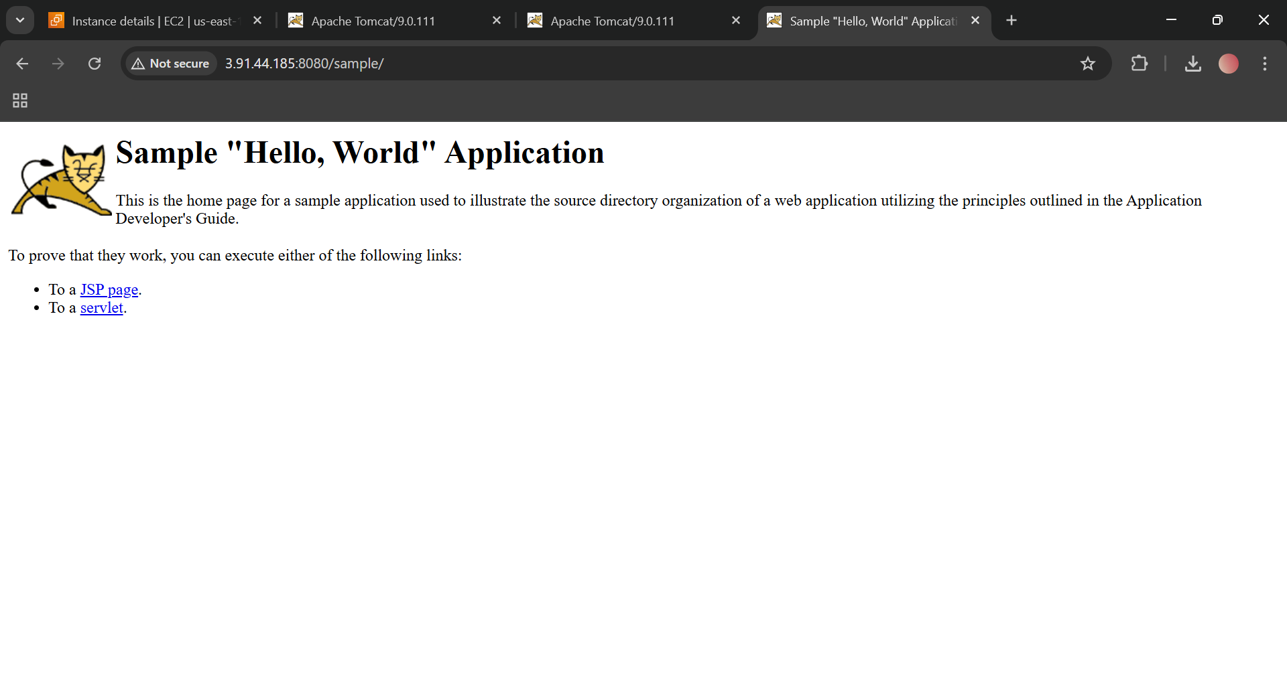

- Create a tomcat.service file for tomcat.
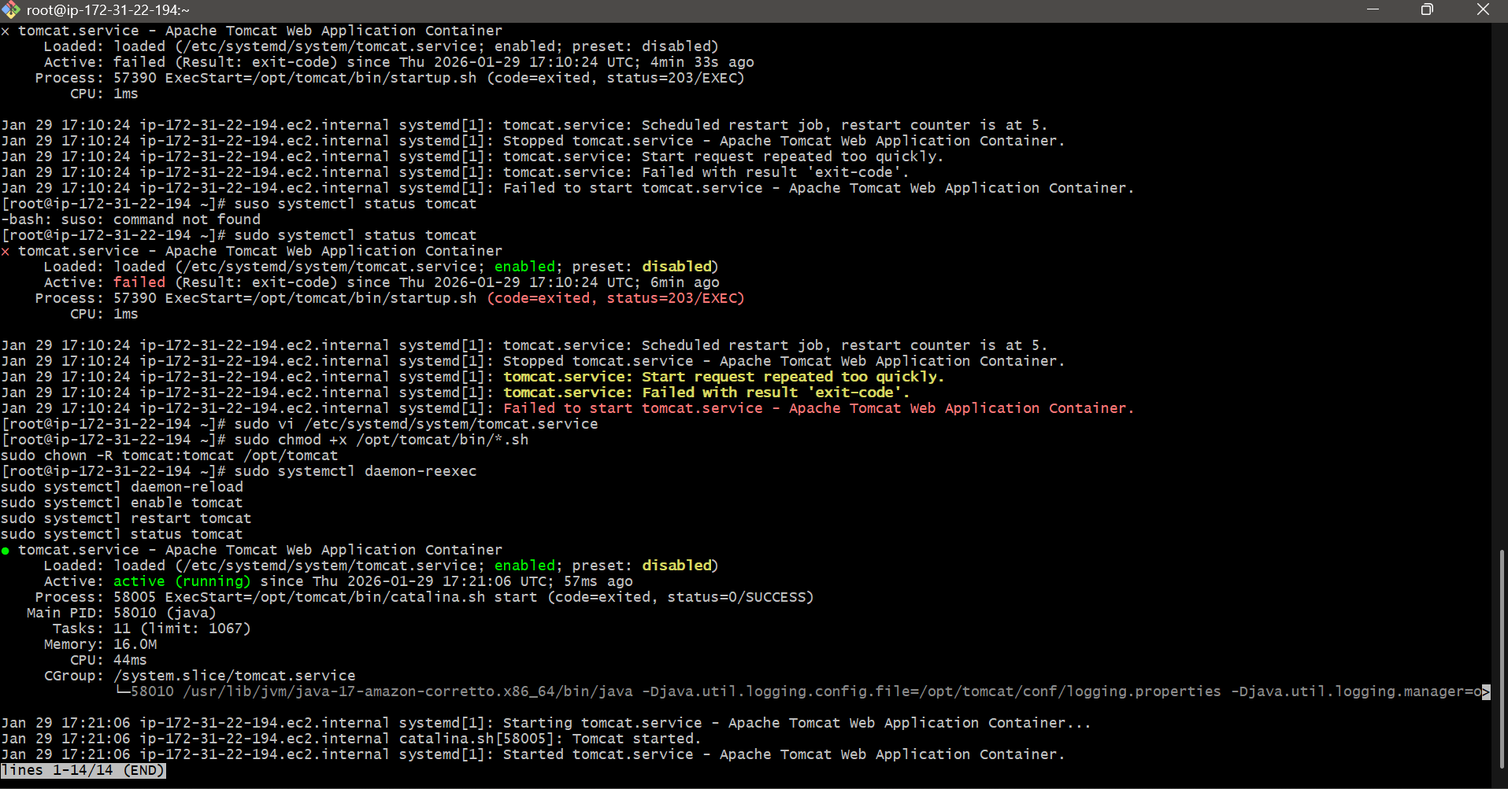
- Configure HA Proxy server
